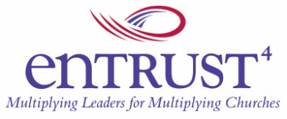

Group Training Roster for Entrust Modules
We appreciate your cooperation in completing our training roster. The information you provide will be held in strict confidence and will not be used for the solicitation of funds. It is used to evaluate the impact and scope of our training and as the basis for verifiable, statistical information that is needed for our board of directors and others who help make this training possible.

Lead Facilitator
Name:
Email:
Phone:

Co-Facilitator
Name:
Email:
Phone:

Module Being Offered (please complete a separate form for each module offered): ______________________

Dates
From (mm/dd/yyyy): _______________
To (mm/dd/yyyy): _______________
Frequency (i.e., weekly, bi-monthly, monthly, etc.): _______________

Order Payment Method (Through Entrust Website, Check, Invoice)
_______________ (eTapestry Receipt Number, Check # or Invoice #)

Location of Training
City: State: Country:

Please list the participants involved in this training. Send completed form to grouproster@entrust4.org. If anyone withdraws from the training or does not complete it successfully, please email us the names at grouproster@entrust4.org.
If copies are to be shipped individually to participants, please give individual addresses in the comment section when you place the order.

Names of Participants
Name:
Email:
Church:

Name:
Email:
Church:

Name:
Email:
Church:

Name:
Email:
Church:

Name:
Email:
Church:

Name:
Email:
Church:

Name:
Email:
Church:

Name:
Email:
Church:

